ASSIGNMENT-6

1. Calculate the sum of numbers (10 numbers max) & If the user enters a negative number, the loop terminates.

#include<stdio.h>

int main()

{

int num, i, sum=0;

printf("Enter number: ");

for(i=0;i<10;i++)

{

scanf("%d",&num);

sum= sum+num;

if( num<0 )

break;

}

printf("Sum of the given number:%d",sum);

return 0;

}

Output:-

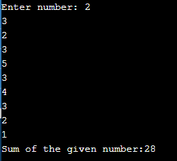

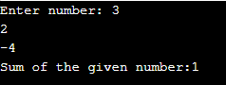

2. Calculate the sum of numbers (10 numbers max) & If the user enters a negative number, it's not added to the result.

#include<stdio.h>

int main()

{

int num, i, sum=0;

printf("Enter number: ");

for(i=0;i<10;i++)

{

scanf("%d",&num);

if( num<0 )

continue;

sum=sum+num;

}

printf("Sum=%d",sum);

return 0;

}

Output:-

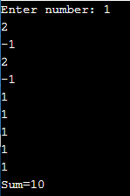

3. Take input from the user until he/she enters zero. (Using Break)

#include <stdio.h>

int main()

{

int num,i;

printf("enter the number: ");

while(1)

{

scanf("%d",&num);

if(num==0)

break;

}

return 0;

}

Output:-

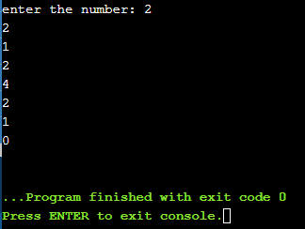

4. Check whether the given number is prime or not.(Using Break)

#include <stdio.h>

int main()

{

int num, i, count = 0;

printf("Enter the number: ");

scanf("%d", &num);

for (i = 2;i<=num/2;++i)

{

if (num % i == 0)

{

count = 1;

break;

}

}

if (count == 0)

printf("%d is a prime number", num);

else

printf("%d is not a prime number", num);

return 0;

}

Output:-

pri.png

5. Print sum of odd numbers between 0 and 10. (Using Continue)

#include <stdio.h>

int main ()

{

int i,sum = 0;

for (i = 0; i < 10; i++)

{

if ( i % 2 == 0 )

continue;

sum = sum + i;

}

printf("sum of odd number between 0 to 10: %d",sum);

return 0;

}

Output:-

odd.png

6. Check whether the given number is prime or not.(Using Continue)

#include <stdio.h>

int main()

{

int num, i, count = 0;

printf("Enter the number: ");

scanf("%d", &num);

for (i = 2;i<=num/2;++i)

{

if (num % i == 0)

{

count = 1;

continue;

}

}

if (count == 0)

printf("%d is a prime number", num);

else

printf("%d is not a prime number", num);

return 0;

}

Output:-

pr.png

gh.png

7. Print all even numbers from 1 to 100. (Using Continue)

#include <stdio.h>

int main ()

{

int i;

printf("even numbers between 0 and 100: ");

for(i=0;i<=100;i++)

{

if(i%2!=0)

continue;

printf("%d\n",i);

}

return 0;

}

Output:-

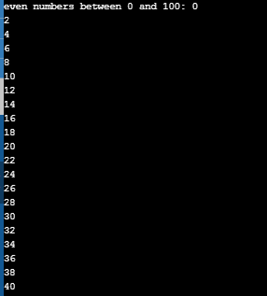

8. Print numbers from 1 to 10 using goto statement. (Using goto)

#include <stdio.h>

int main()

{

int count=1;

start:

printf("%d ",count);

count++;

if(count<=10)

goto start;

return 0;

}

Output:-

go.png

9. Program to calculate the sum and average of positive numbers, If the user enters a negative number, the sum and average are displayed. (Using goto)

#include<stdio.h>

int main()

{

int num,sum=0,avg=0;

printf("Enter the number: ");

start:

scanf("%d",&num);

if(num<0)

goto stop;

sum = sum + num;

//avg=sum/num;

goto start;

stop:

printf("Sum:%d\n",sum);

//printf("Average:%d\n",avg);

return 0;

}

Output:-

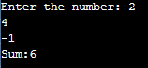

10. Check if a number is even or not. (Using goto)

#include <stdio.h>

void main()

{

int num;

printf("Enter a number");

scanf("%d", &num);

if (num % 2 == 0)

goto even;

else

goto odd;

even:

printf("%d is even\n", num);

odd:

printf("%d is odd\n", num);

}

Output:-

n.png